Hong Kong, China: Recent Economic Developments and Outlook

# GDP growth in 2019 decreased

GDP growth decreased from 2.9% in 2018 to -1.2% in 2019. On the demand side, net exports, accounting for 1.8% of GDP, contributed the most with 2.3 percentage points (pp). Government expenditure gave 0.5pp. On the other hand, gross capital formation and private consumption subtracted 3.3pp and 0.7pp from growth, respectively. On the supply side, agriculture, accounting for nan% of GDP, contributed the most with -0.0pp. However, services and industry (including construction) subtracted 0.3pp and 0.3pp from growth, respectively. Meanwhile, agriculture had trivial contribution to growth this period.

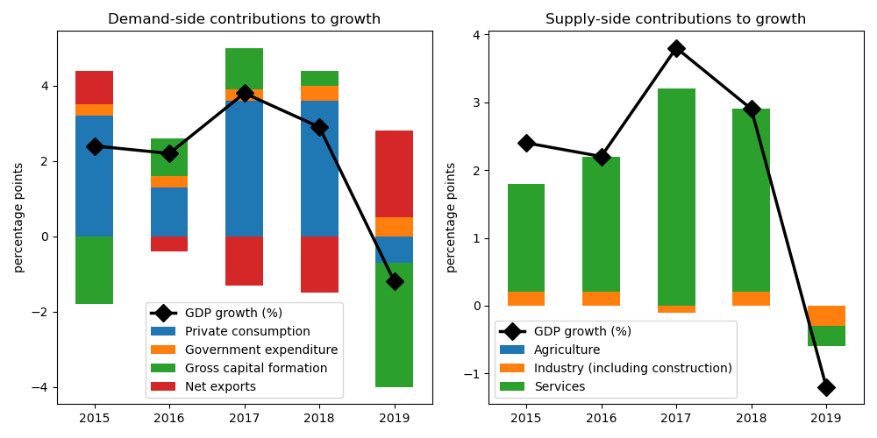

## Government expenditure achieved largest gain on the demand side

Government expenditure jumped by the biggest margin at 5.1% annual growth. On the other hand, private consumption decreased by 1.1%. On the other hand, gross capital formation shrank by 14.9%. On the other hand, net exports plunged by 939.0%.

## On the supply side, growth in agriculture accelerated the fastest

Agriculture declined by the largest edge at -0.1% annual growth. On the other hand, services decreased by 0.3%. On the other hand, industry (including construction) contracted by 3.9%.

## Unemployment improved; inflation increased

Unemployment rate improved from nan% in 2018 to 3.0% in 2019. Consequently, inflation increased from 2.4% to 2.9%. At the end of the year, the central bank set the policy rate at 3.0%.

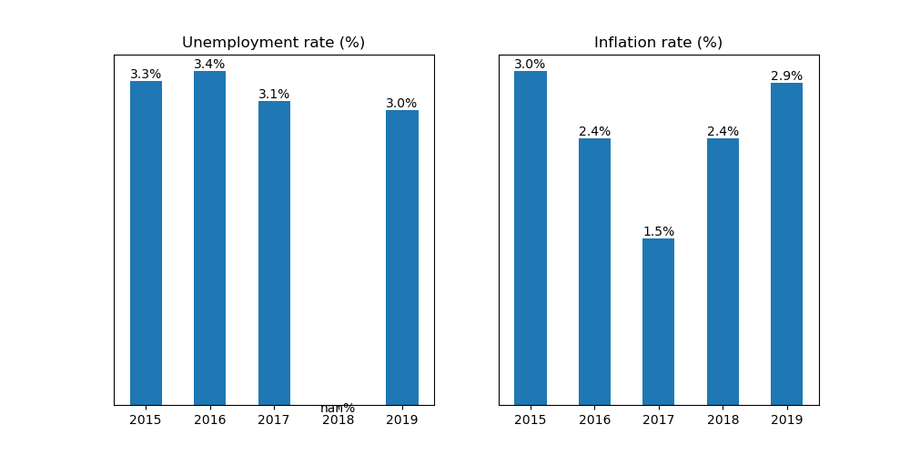

## Current account balance posted a surplus

Current account balance (CAB) recorded a surplus at 6.1% of GDP in 2019. Net trade in goods and services reached USD 6.2 billion. In 2018, CAB posted a surplus at 3.7% of GDP.

China is the country's top export destination accounting for 55.3% of total exports in 2019. Other major exports partners include USA (7.3%), Japan (2.9%), India (2.9%), and Other Asia, nes (2.2%). Top export commodities are electrical machinery and equipment and parts thereof; sound recorders and reproducers; television image and sound recorders and reproducers, parts and accessories of such articles, accounting for 56.2% of total exports.

For imports, top imports origin in 2019 is China (45.7% of total imports), followed by Other Asia, nes (7.3%), Singapore (6.5%), Japan (5.8%), and Rep. of Korea (4.9%). Major import commodities are electrical machinery and equipment and parts thereof; sound recorders and reproducers; television image and sound recorders and reproducers, parts and accessories of such articles, accounting for 53.2% of total imports.

# Output contracted in Q3 2020

Output plunged by 3.4% year-on-year in Q3 of 2020. Growth in overall economic activity improved from a contraction of 9.1% in the previous quarter. Government expenditure picked up by the biggest margin at 6.9% annual growth. On the other hand, private consumption decreased by 8.1%.

## Retail sales contracted

Retail sales contracted by 8.3% year-on-year in October of 2020. Growth in the retail sector increased from a contraction of 12.7% in September, reflecting increased trade activity.

## Industrial output shrank

Manufacturing shrank by 3.2% year-on-year in June, a decrease from -2.1% growth in the previous month.

## Inflation improved

Overall inflation improved to -1.6% year-on-year in October from -1.4% in the previous month.

Hong Kong, China's central bank held unchanged the official policy rate to 1.75% in November from the same in October.

# Outlook tilted downwards this year

On November 2020, Consensus Economics panelists project Hong Kong, China's economic growth ending in 2020 at -6.2%. In 2021, the panelists foresee growth at 4.4%. Over the same period, consumption is expected to grow by -9.2% and 5.7%, while investment is projected to grow by -13.3% and 5.8%.

Meanwhile, Consensus Economics panelists foresee inflation averaging in 2020 at 0.6%. In 2021, the panelists project inflation at 1.6%.

*Sources: Consensus Economics, The World Bank, UN Comtrade, Haver Analytics, and National Sources. Accessed 05 December 2020.*